**B.Tech. CSE (III YEAR – V SEM) (2025-2026)**

**DEPARTMENT OF COMPUTER ENGINEERING & APPLICATIONS**

**GLA University**

**17km Stone, NH-19, Mathura-Delhi Road P.O. Chaumuhan,**

**Mathura – 281406**

**(Uttar Pradesh) India**

**Project Title**

**AI-Based Voice Command Home Automation**

**Team Member 1:** Nitin Kumar **UID:** 2315800055

**Team Member 2:** Aditya Pratap Singh **UID:** 2315800005

**Team Member 3:** Aditya Pachaury  **UID:** 2315800004

**Mentor Name:** Dr. Yunis Lone Ahmad

**Signature: ______________**

**Project Synopsis: AI-Based Voice Command Home Automation**

**0. Cover**

* **Project title:** AI-Based Voice Command Home Automation.
* **Team name & ID:** Team Sigma (T11)
* **Institute / Course:** GLA University, B.Tech CS (Hons.)
* **Version:** v0.1
* **Date:** 29 Aug 2025

**Revision history**

|  |  |  |  |
| --- | --- | --- | --- |
| **Version** | **Date** | **Author** | **Change** |
| v0.1 | 29 Aug 2025 | T11 | Initial draft |

**1. Overview**

**1.1 Problem statement:** Traditional home automation systems require manual control (switches, apps, or remotes) and lack personalization. Existing voice assistants (Alexa, Google Home) depend heavily on cloud, which raises privacy concerns, and they don’t adapt well to individual users’ habits.

**1.2 Goal:** The proposed Voice Command Home Automation System provides a smart, hands-free way to control home appliances, lights, and security systems. The system begins by capturing user input through speech-to-text processing, converting spoken words into digital text. Using Natural Language Understanding (NLU), it identifies the intent behind the command—for example, recognizing “Goodnight” as a request to turn off lights, lock doors, and activate the alarm.

**1.3 Non‑goals:** In v1, we will not focus on advanced features like proactive device control based on user mood, or integration with external services like music streaming.

**1.4 Value proposition:** A secure, local-first voice control system that enables easy, natural language interaction for controlling home appliances, lights, and security.

**2. Scope and Control**

**2.1 In‑scope**

* + Speech-to-text processing for voice commands.
  + Natural Language Understanding (NLU) for intent recognition.
  + Integration with a minimum of two device types (e.g., smart lights, smart plugs).
  + Support for pre-defined routine scheduling (e.g., "Goodnight" routine).
  + A simple mobile app for remote control.

**2.2 Out‑of‑scope**

* + Support for a wide range of devices beyond the initial scope.
  + Biometric voice recognition for multiple users.
  + Advanced machine learning models for user habit prediction.

**2.3 Assumptions**

* + The system will run on a local network hub (e.g., Raspberry Pi).
  + The user's home has a stable Wi-Fi network.
  + The integrated smart devices have public or local APIs.

**2.4 Constraints**

* + 10-week timeline.
  + Limited budget for hardware.
  + Team skills are beginner-level in AI/ML model training.

**2.5 Dependencies**

* + Access to an open-source or commercial speech-to-text API.
  + Availability of a Raspberry Pi or similar single-board computer.

**2.6 Acceptance criteria and sign‑off**

* + **Acceptance Criteria:**
* GIVEN a user says a command like "Hey Home, Turn on the living room light" WHEN the system hears the command THEN the light turns on within 3 seconds.
* GIVEN a user says "Hey Home, Goodnight" WHEN the command is processed THEN all specified lights turn off and the smart lock engages.
  + **Signoff:** Mentor approval of the demo and a completed test report. All P1 bugs are closed.

**Sign‑off table**

|  |  |  |  |  |
| --- | --- | --- | --- | --- |
| **Stakeholder** | **Role** | **Decision area** | **Signature/Approval** | **Date** |
| Dr. Yunis Lone Ahmed | Mentor | Scope, final acceptance | Approved | 28 Aug 2025 |
| Nitin Kumar | Product Lead | Release readiness | Approved | 26 Aug 2025 |

**3. Stakeholders and RACI**

|  |  |  |  |  |
| --- | --- | --- | --- | --- |
| **Activity** | **Responsible (R)** | **Accountable (A)** | **Consulted (C)** | **Informed (I)** |
| **Requirements** | Aditya Pratap Singh | Nitin Kumar | Mentor | Team |
| **Design** | Nitin Kumar, Aditya Pachaury | Nitin Kumar | Mentor | Team |
| **Implementation** | Aditya Pachaury | Aditya Pachaury | Mentor | Team |
| **Testing** | Aditya Pratap Singh | Aditya Pratap Singh | Mentor | Team |
| **Release** | Team | Team | Mentor | Dept |

**4. Team and Roles**

|  |  |  |  |  |  |
| --- | --- | --- | --- | --- | --- |
| **Member** | **Role** | **Responsibilities** | **Key skills** | **Availability** | **Contact** |
| **Nitin Kumar** | Product Lead & IoT Specialist | System design, project planning, API contracts, documentation, coordination | Product design, REST APIs, IoT basics | 8 hrs/wk | [email](mailto:Nitinkumarbtp514@gmail.com) |
| **Aditya Pratap Singh** | Frontend (Android - Java),IOT | Android app (Java), UI/UX design, API integration, device control & status screens | Android (Java), Android Studio, MQTT, XML layouts | 10 hrs/wk | [email](mailto:adityasingh000029@gmail.com) |
| **Aditya Pachaury** | Backend,IOT | IoT architecture, device communication (ESP32), API development, database, security | Node/Express, Python Flask, SQL, MQTT, ESP32 | 10 hrs/wk | [email](mailto:adityapachaury001@gmail.com) |

**5. Week‑wise Plan and Assignments**

|  |  |  |  |  |  |  |
| --- | --- | --- | --- | --- | --- | --- |
| **Week** | **Dates** | **Nitin Kumar** | **Aditya Pratap Singh** | **Aditya Pachaury** | **Deliverables** | **Status** |
| **1** | 1–7 Sep | Finalize project scope, gather requirements, check feasibility (voice + IoT + app). | Prepare wireframes for mobile app (ON/OFF, status screen). | Research APIs (Whisper API, HuggingFace LLMs, ESP32 libraries). | Draft SRS (Software Requirement Specification). | Planned |
| **2** | 8–14 Sep | Prepare system architecture & workflow diagram. | Define API contracts (Laptop/Whisper → ESP32 → Relay). | Define API contracts (Laptop/Whisper → ESP32 → Relay). | Architecture Diagram + ERD + API Spec v1. | Planned |
| **3** | 15–21 Sep | Setup Whisper API in laptop | Authentication screen for app (login/signup if needed). | Build module: Speech → Text → Intent (“Turn ON/OFF light”). | Working voice-to-text prototype. | Planned |
| **4** | 22–28 Sep | Setup ESP32 with WiFi + Relay. Test manual ON/OFF via code. | Build app shell (basic navigation: Home, Devices). | Create API to send command from laptop → ESP32. | Laptop/App can control relay via ESP32. | Planned |
| **5** | 29 Sep–5 Oct | Integrate speech recognition + IoT. | Add device control screen (ON/OFF switch UI). | Implement full flow: Speech → Intent → Command → ESP32. | Demo: Speak → Light turns ON/OFF. | Planned |
| **6** | 6–12 Oct | Add multi-device support (fan, bulb). | Add status indicator (Light ON/OFF shown in app). | Add HTTP/REST support for stable communication. | Feature B Demo (multi-device control). | Planned |
| **7** | 13–19 Oct | Identify risks (network failure, API delays). | Polish UI, add error messages. | Optimize code for faster response. | Tested stable prototype. | Planned |
| **8** | 20–26 Oct | Prepare project documentation & presentation. | Final UI polish + animations. | Final API cleanup + code comments. | Final Project Demo + Report Submission. | Planned |

**6. Users and UX**

**6.1 Personas**

* **New Seller Sam:** Wants to use voice commands to control her home without lifting a finger. Values speed and reliability.
* **Bargain Buyer Bella:** Values secure, local processing and wants to use voice commands for doors and alarms.

**6.2 Top user journeys**

* **Lights:** User says "Turn on the lights" -> System processes command -> Lights turn on.
* **Routine:** User says "Goodnight" -> System processes routine -> Lights off, doors lock.

**6.3 User stories**

* As a user, I want to control my lights with a voice command so I don't have to get up to use a switch.
* As a user, I want to set up a "Goodnight" routine so I can turn off multiple devices with a single command.

**7. Market and Competitors**

**7.1 Competitor table**

|  |  |  |  |  |  |  |  |
| --- | --- | --- | --- | --- | --- | --- | --- |
| **Competitor** | **Product** | **Target users** | **Key features** | **Pricing** | **Strength** | **Weakness** | **Our differentiator** |
| **Google Home / Alexa** | C2C marketplace | General households | Voice control, device integration, routines | Device cost + free app | Wide ecosystem, strong AI | Privacy concerns, limited offline use | More secure, offline-first features |
| **Apple HomeKit** | C2C marketplace | General households | Multi‑category | Device cost + free app | Strong privacy, seamless UX | Limited device support, costly devices | Affordable + broader device support |
| **Samsung SmartThings** | Social C2C | Smart home platform | Device hub, automation, IoT integrations | Device cost | Strong privacy, seamless UX | Complex setup for beginners | Simple setup for non-tech users |

**7.2 Positioning**

* **Unique angle:** A voice assistant focused on local control and privacy, designed specifically for home automation tasks.
* **Measurable delta:** Our system processes commands locally, reducing latency and minimizing reliance on an internet connection, ensuring faster and more reliable responses.

**8. Objectives and Success Metrics**

* **O1 Latency:** Command-to-action latency of less than 3 seconds.
* **O2 Accuracy:** Intent recognition accuracy of 95% for core commands.
* **O3 Reliability:** System uptime of 99.0%.

**9. Key Features**

|  |  |  |  |  |
| --- | --- | --- | --- | --- |
| **Feature** | **Description** | **Priority** | **Dependencies** | **Acceptance criteria** |
| **Local Voice Control** | Control lights, fans, and devices via voice locally | Must | Speech-to-text, Device APIs | GIVEN command WHEN spoken THEN device responds in ≤ 1 s without internet |
| **Device Management** | Add, remove, group devices for easy control | Must | Auth, Local DB | GIVEN device WHEN added THEN visible in dashboard and controllable |
| **Automation Rules** | Set schedules and triggers (e.g., lights on at 7 PM) | Should | Device Management | GIVEN rule WHEN condition met THEN automation executes within 2 s |
| **Privacy Settings** | Manage permissions and data storage locally | Must | Auth | GIVEN settings WHEN updated THEN data remains local and permissions apply instantly |
| **Mobile Dashboard** | App dashboard to monitor and control devices | Should | Local Network | GIVEN dashboard WHEN opened THEN status of devices is updated in real time |
| **Alerts & Reports** | Send local notifications on unusual activity | Could | Device Management | GIVEN event WHEN unusual activity occurs THEN notification shown in ≤ 3 s |

**10. Architecture**

**10.1 High level**

* **Clients:** React SPA (Single Page Application) providing the user interface for students to access the marketplace.
* **Services:** Auth service for registration, login, and verification; Listing service to handle CRUD operations on items; Search API to support keyword, category, and price-based queries.
* **Data stores:** MySQL as the main relational database for structured data; Object storage for images and other static assets.
* **Integrations:** SMTP for sending email verifications and notifications; optional campus SSO for seamless login with institutional credentials.

**10.2 API spec snapshot**

|  |  |  |  |  |  |  |
| --- | --- | --- | --- | --- | --- | --- |
| **Endpoint** | **Method** | **Auth** | **Purpose** | **Request schema** | **Response schema** | **Codes** |
| **Google Speech Recognition API** | POST | — | audio to text | ------ | 200 | 201, 400 |

**10.3 Config and secrets**

**10.3.1 Configuration (Config):**

* Non-sensitive settings that vary between environments (dev, test, prod).
* Example: APP_PORT=8080, LOG_LEVEL=debug.

**10.3.2 Secrets:**

* Sensitive data that must not be hardcoded in code or shared publicly.
* Example: DB_PASSWORD=xyz123, API_KEY=abcd-efgh.

**11. Data Design**

**11.1 Data dictionary**

|  |  |  |  |  |  |  |
| --- | --- | --- | --- | --- | --- | --- |
| Entity | Field | Type | Null? | Allowed values | Source | Notes |
| User | id | UUID | No | — | System | PK |
| User | email | String | No | RFC 5322 | User | Unique |
| Listing | id | UUID | No | — | System | PK |
| Listing | title | String(120) | No | — | Seller | Indexed |
| Listing | price | Decimal(10,2) | No | ≥ 0 | Seller | — |

**12. Technical Workflow Diagram**

* 1. **State Transition Diagram** 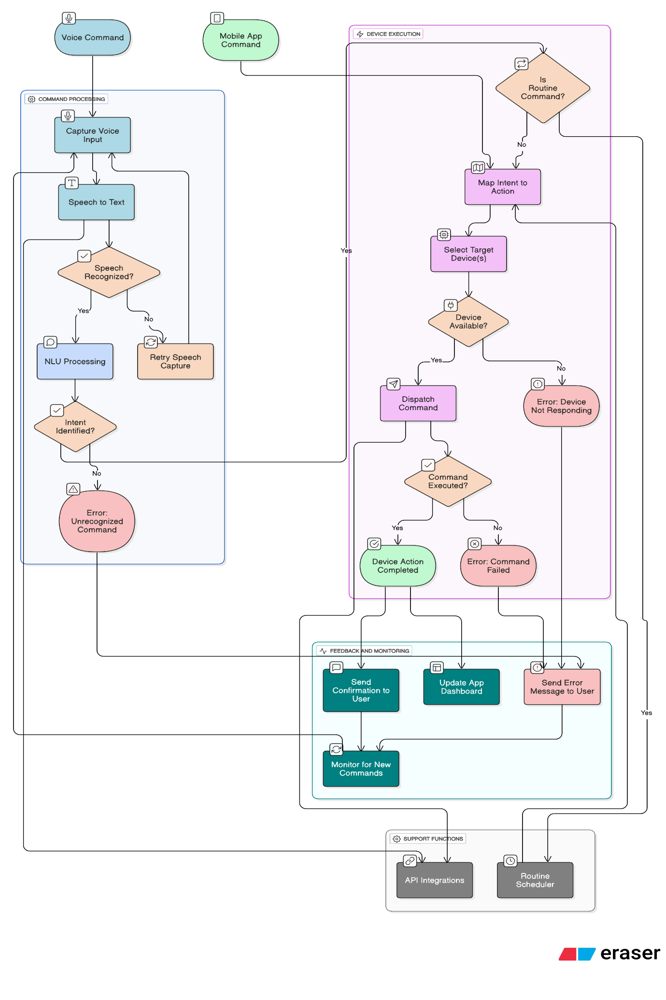

**12.2 Sequence Diagram**

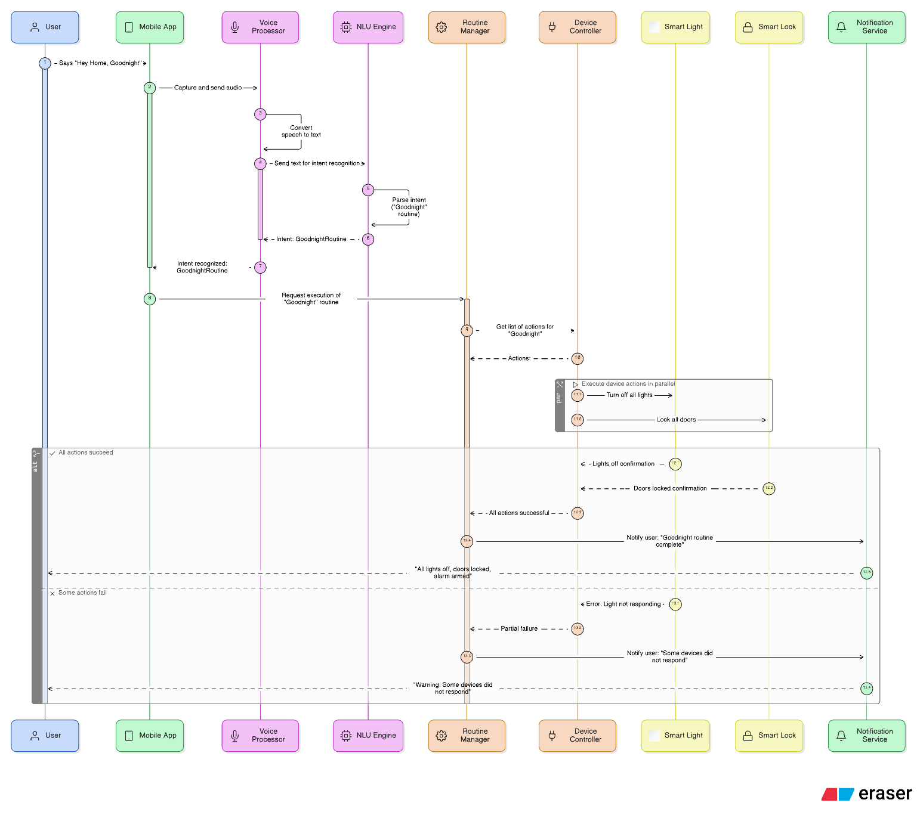

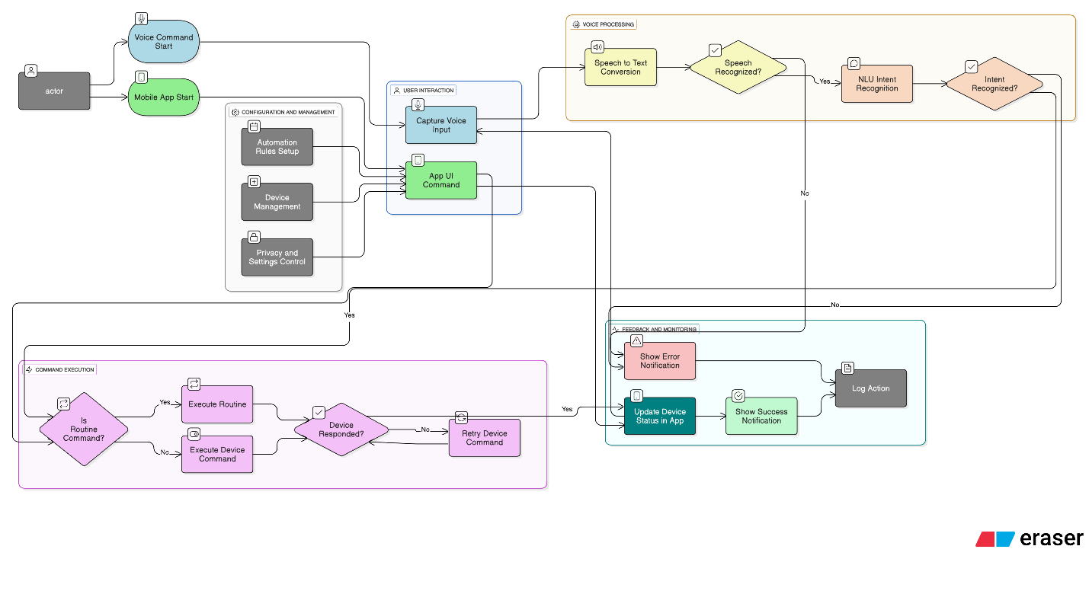**12.3 Use Case Diiagram**

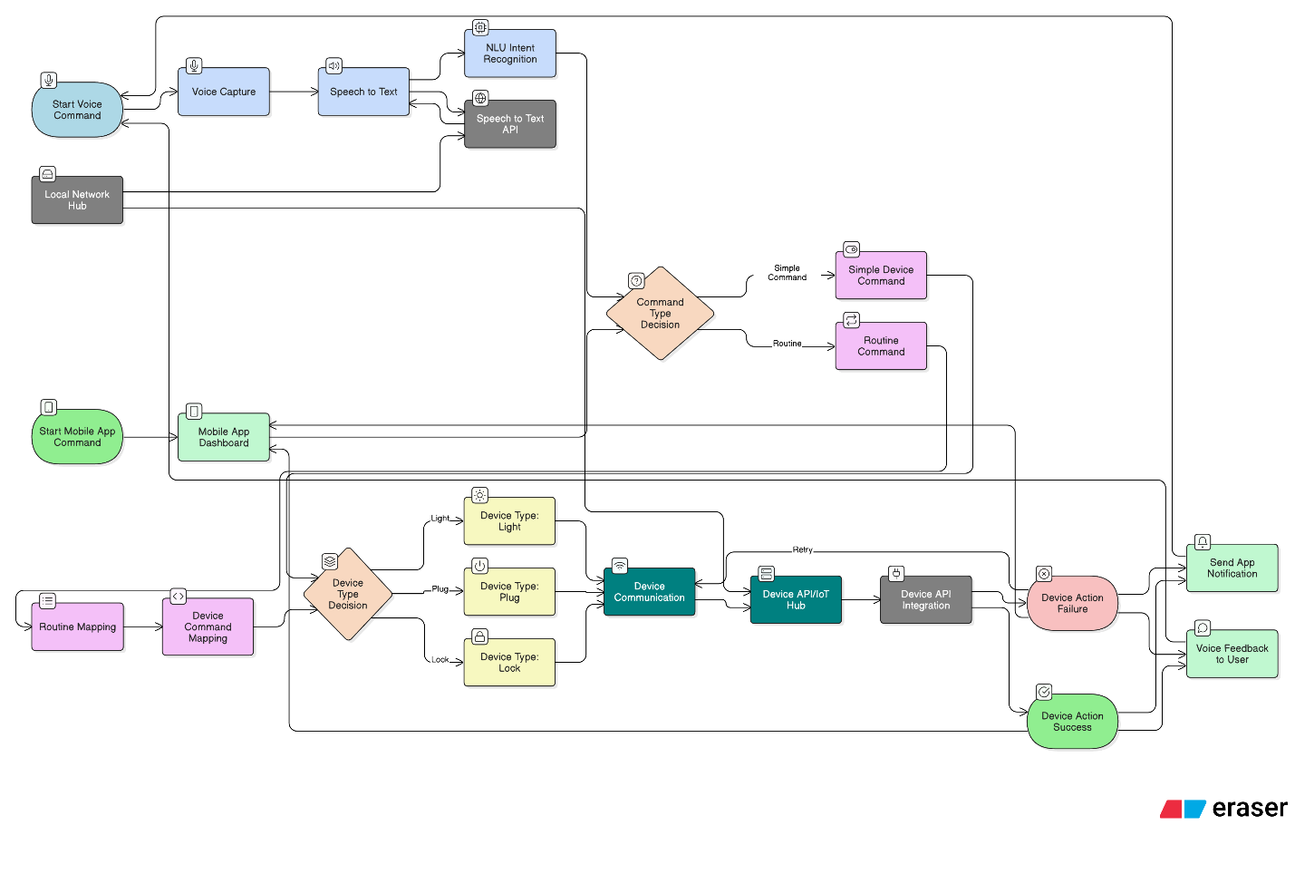**12.4 Data Flow Diagram**

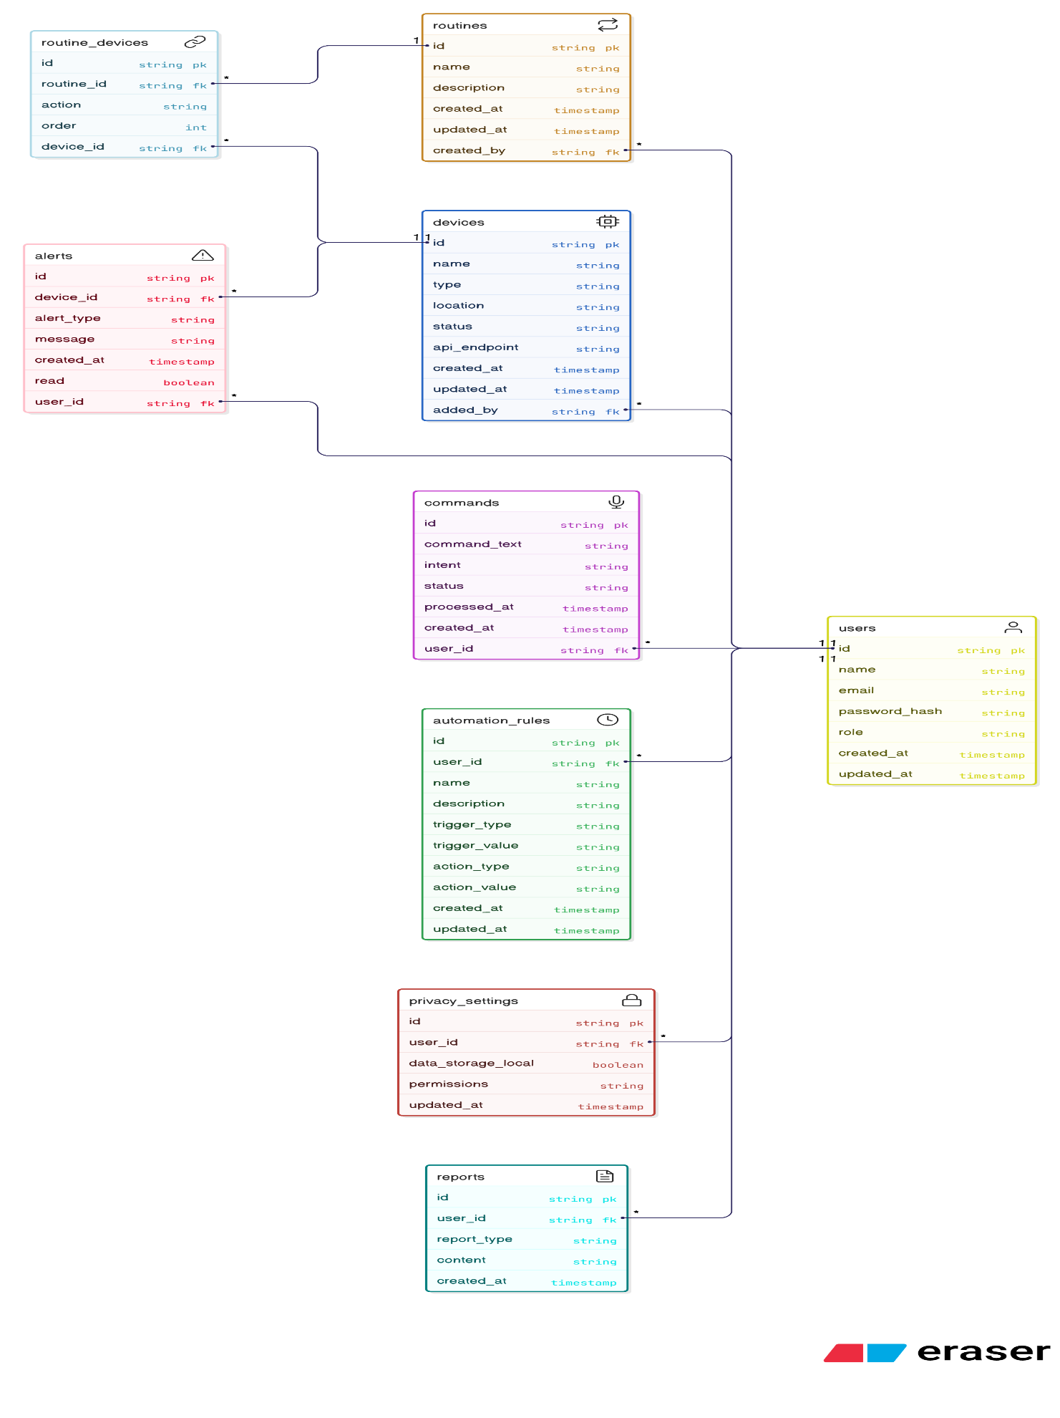**12.5 ER Diagram**

**13. Security and Compliance**

**13.1 Threat model (STRIDE)**

|  |  |  |  |  |
| --- | --- | --- | --- | --- |
| **Asset** | **Threat** | **Impact** | **Mitigation** | **Owner** |
| **Raspberry Pi Hub** | Unauthorized physical/network access | High | Strong password for OS, secure local network config, physical security | Nitin Kumar |
| **Voice Command Text (NLU input)** | Command text intercepted on local network | High | No voice recordings stored, text processed locally (not transmitted externally) | Aditya |

**13.2 Authentication & Authorization (AuthN/AuthZ)**

* **AuthN:** Involves a strong password during Raspberry Pi hub setup and a one-time secure pairing for the mobile app. No email/password or cloud-based authentication is used for daily operation.
* **AuthZ:** The single user acts as an administrator with full control. Future versions might add basic roles (e.g., Admin, Guest) with access checks at the local API layer.

**13.3 Audit & Logging**

The system logs critical events locally on the Raspberry Pi hub for stability and debugging.

* **Logged Events:** Includes system startup, command execution, routine runs, device status changes, app connections, and errors.
* **Privacy:** No raw voice data or other sensitive PII is logged.
* **Retention:** Logs are kept for a maximum of 30 days locally with rotation.

**13.4 Compliance**

* **Data Privacy:** A core principle is local data processing and storage. No third-party data sharing occurs, minimizing external compliance concerns by keeping all data within the user's home network.

**14. Risks and Mitigations**

**14.1 Risk heatmap**

|  |  |  |  |  |  |  |
| --- | --- | --- | --- | --- | --- | --- |
| **Risk** | **Probability** | **Impact** | **Score** | **Mitigation** | **Owner** | **Status** |
| **Schedule slip** | Medium | High | 12 | Scope freeze, weekly demos, agile sprints | Nitin Kumar | Open |
| **DB performance** | Medium | High | 11 | Focus on core commands first, expand training data incrementally | Aditya Pratap Singh | Open |
| **Image storage costs** | Medium | Medium | 11 | Optimize queries, appropriate indexing, monitor Raspberry Pi load | Aditya Pachaury | Open |

**15. Research and Evaluation**

* 1. **Research:** Analyze existing voice assistants and smart home hubs.

**15.2 Evaluation:** Track success metrics (latency, accuracy, reliability) and gather user feedback.

**16. Appendices**

* 1. **Glossary:** NLU, STT, IoT.

**16.2 References:** What is Natural Language Understanding (NLU) from Replicant. URL: *https://www.replicant.com/glossary/what-is-natural-language-understanding*

How to integrate Google Smart Home API with your IoT devices?" from BriteHome. URL: *https://britehome.tech/integrate-google-smart-home-api-with-iot-devices/*

Speech Recognition In IoT Devices from Meegle. URL: *https://www.meegle.com/en_us/topics/speech-recognition/speech-recognition-in-iot-devices*